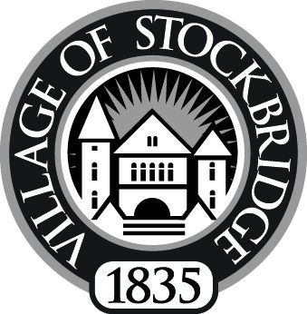

STOCKBRIDGE DOWNTOWN DEVELOPMENT AUTHORITY
Executive Committee Meeting ~ 134 East Main
Tuesday, July 13, 2010 ~ 8:00 AM
“Unapproved Minutes”

8:05 am CALL TO ORDER BY CHAIR ANNABELL HOWARD ~
- ROLL CALL TAKEN - Present: Chair Annabell Howard, Secretary Scott Spadafore, Tom Lovachis
- PLEDGE OF ALLEGIANCE

DISCUSSION
- Façade Program
- Garbage contract/Wood Street parking lot
- Industrial Park mowing
- Village contract resolution
- Pros/cons on getting someone to market Stockbridge
- Check to see how much we have spent on Desine, Inc.
- Dumpster cleanup on Wood Street
- Recycling project

PUBLIC COMMENT
- None

ADJOURNMENT: 9:25 a.m.

Annabell Howard, Chair

